**MATLAB/Octave:**

**Plotting a Function:**this is the simple script to plot a sine function.

**Code:**

% Create an array of x values from -2*pi to 2*pi

x = linspace(-2*pi, 2*pi, 100);

% Compute the sine of each x value

y = sin(x);

% Create a plot of x against y

figure;

plot(x, y);

title('Plot of Sine Function');

xlabel('x');

ylabel('sin(x)');

**Screenshot:  
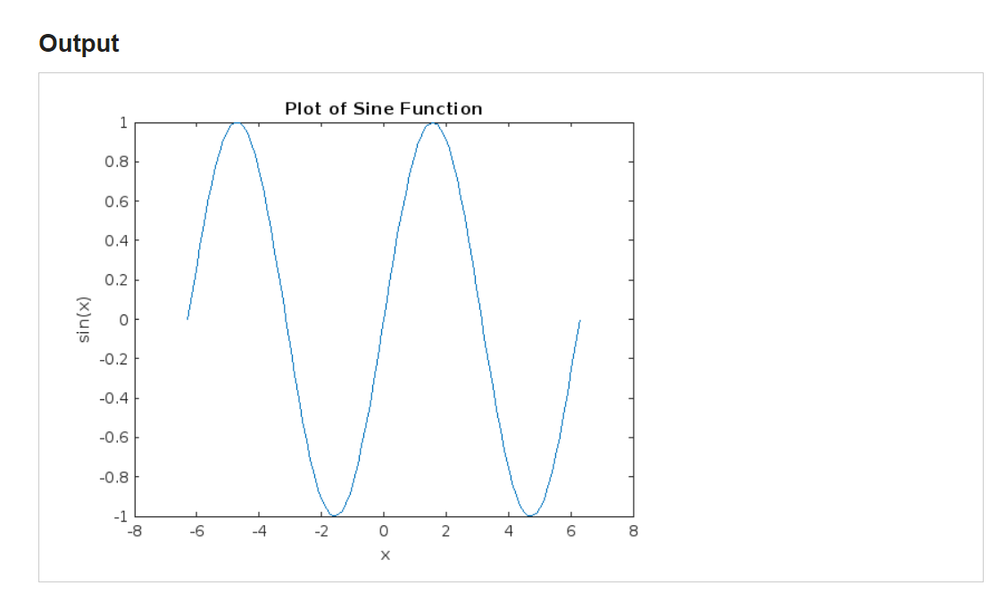**

**Salting a Function:**

Added random noise to the sine function to salt it:

**Script:**

% Create an array of x values from -2*pi to 2*pi

x = linspace(-2*pi, 2*pi, 100);

% Compute the sine of each x value

y = sin(x);

% Generate random noise of the same size as y

noise = 0.5 * randn(size(y));

% Add noise to the original y values to create a salted function

y_salted = y + noise;

% Plot the original and salted function

figure;

plot(x, y, 'b', x, y_salted, 'r--');

title('Sine Function and Salted Sine Function');

xlabel('x');

ylabel('Function Value');

legend('Original Sine', 'Salted Sine');

**ScreenShot:  
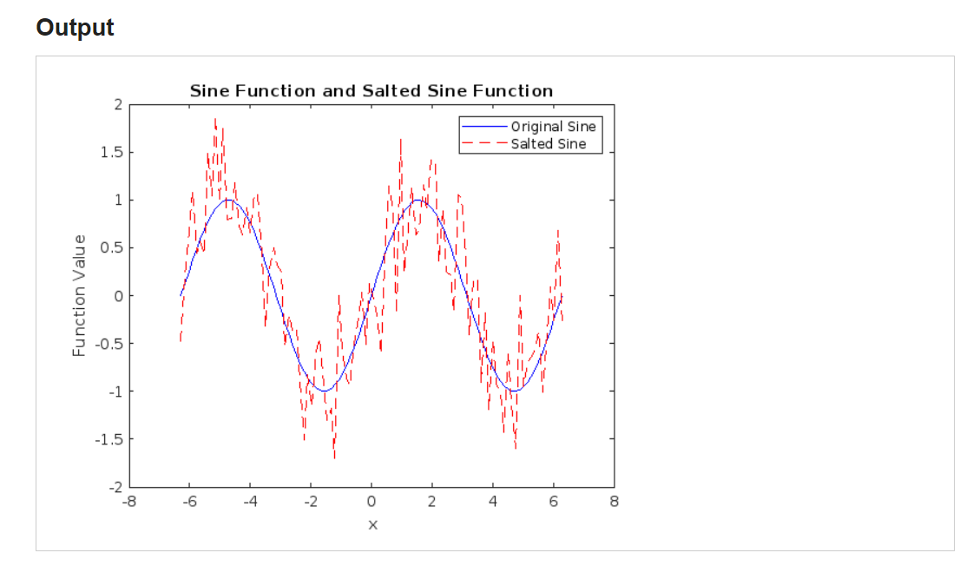**

**Smoothing a Function:**

Now applied simple moving average to smooth the above salted function.

**Script:**

% Create an array of x values from -2*pi to 2*pi

x = linspace(-2*pi, 2*pi, 100);

% Compute the sine of each x value

y = sin(x);

% Generate random noise of the same size as y

noise = 0.5 * randn(size(y));

% Add noise to the original y values to create a salted function

y_salted = y + noise;

% Define the window size for the moving average

windowSize = 10;

% Create a simple moving average filter

b = (1/windowSize) * ones(1, windowSize);

a = 1;

% Apply the filter to the salted function

y_smoothed = filter(b, a, y_salted);

% Plot the smoothed function

figure;

plot(x, y_smoothed);

title('Smoothed Sine Function');

xlabel('x');

ylabel('Smoothed Salted sin(x)');

**ScreenShot:**

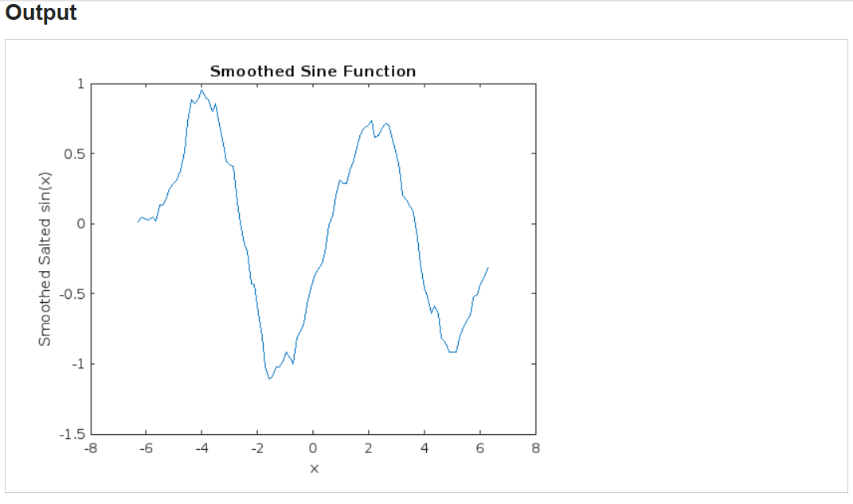

**JAVA :**

**Function Plot:**

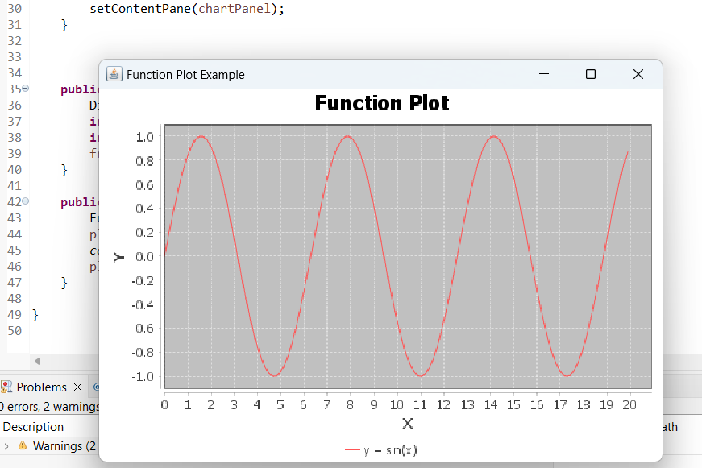

**Function Salting:**

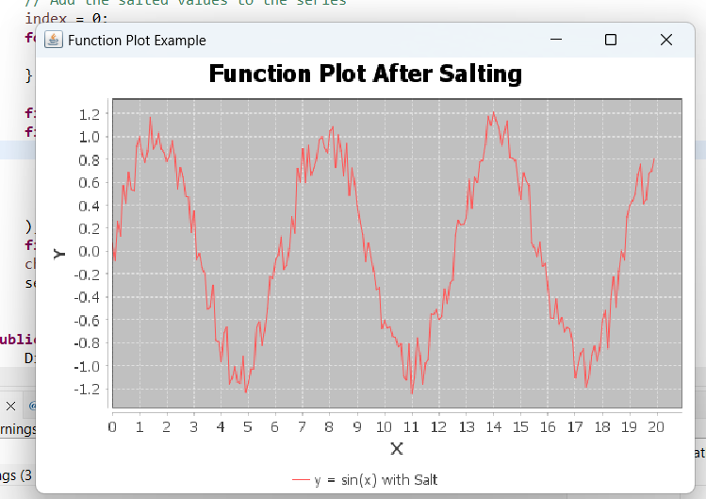

**Function Smoothing:**

